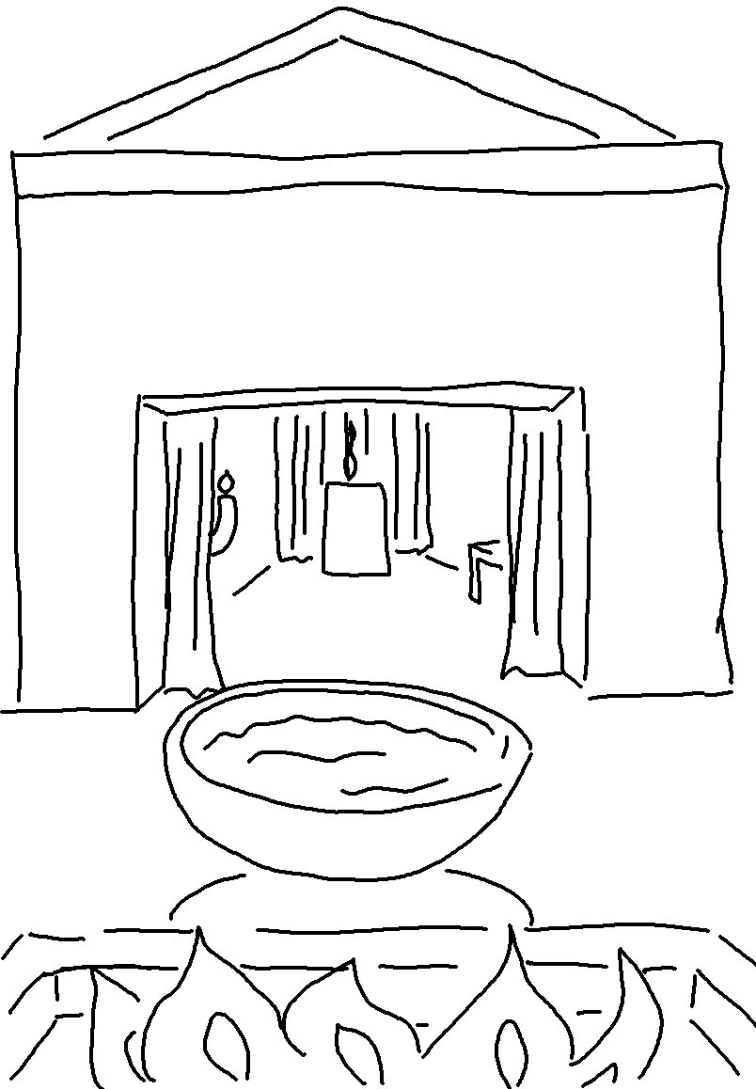

In 2 Chronicles 2:5_{CEV} Solomon said: "This will be a great temple, because our _ _ _ is _ _ _ _ _ _ _ than all other gods.

